

SEDL 8500
Test Plan Document

Prepared by: Mike Hasbrouck

- Using SA GUI Update QRM settings for a user

- Navigate from the Start button to User tab to User Management tab

- Select a user (any user that has valid firm and is enabled) where there is only a default QRM

- Open QRM tab

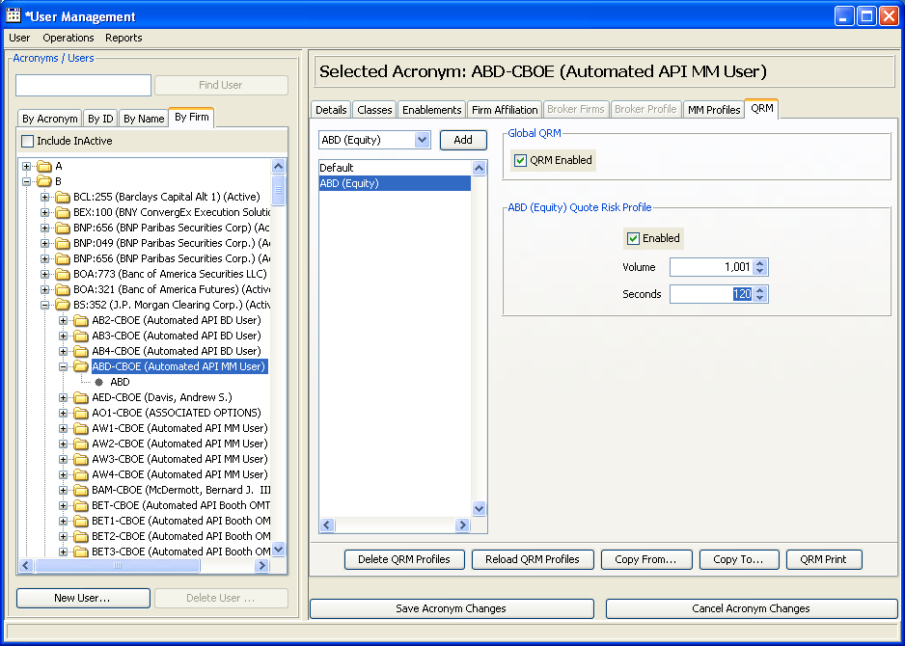

- Add various types of classes (Equity,Option,Strategy,Index,Future) for a class symbol

- Set QRM Enabled and set the Enabled checkbox. The numerical values can be any for volume and seconds

- Save Acronym changes using the button on bottom

- Update all the numerical values for each class type added

- Save Acronym changes using the button on bottom

- Select by highlighting all added and updated class types and click Delete QRM Profiles

- Save Acronym changes using the button on bottom

- From the $RUN_DIR directory on the testing environment run this script with these parameters
createQRMUpdateReport global TheTestersCboeEmailAddress
For Example: createQRMUpdateReport global hasbromj@cboe.com

- The report should look something like this in the testers Outlook email :
** For this example, I had updated User : M912

